Product Sketches #1: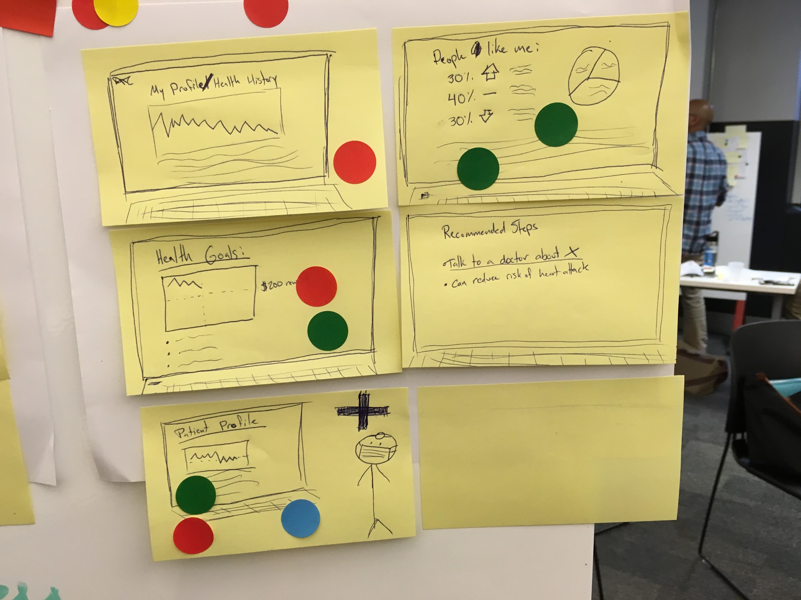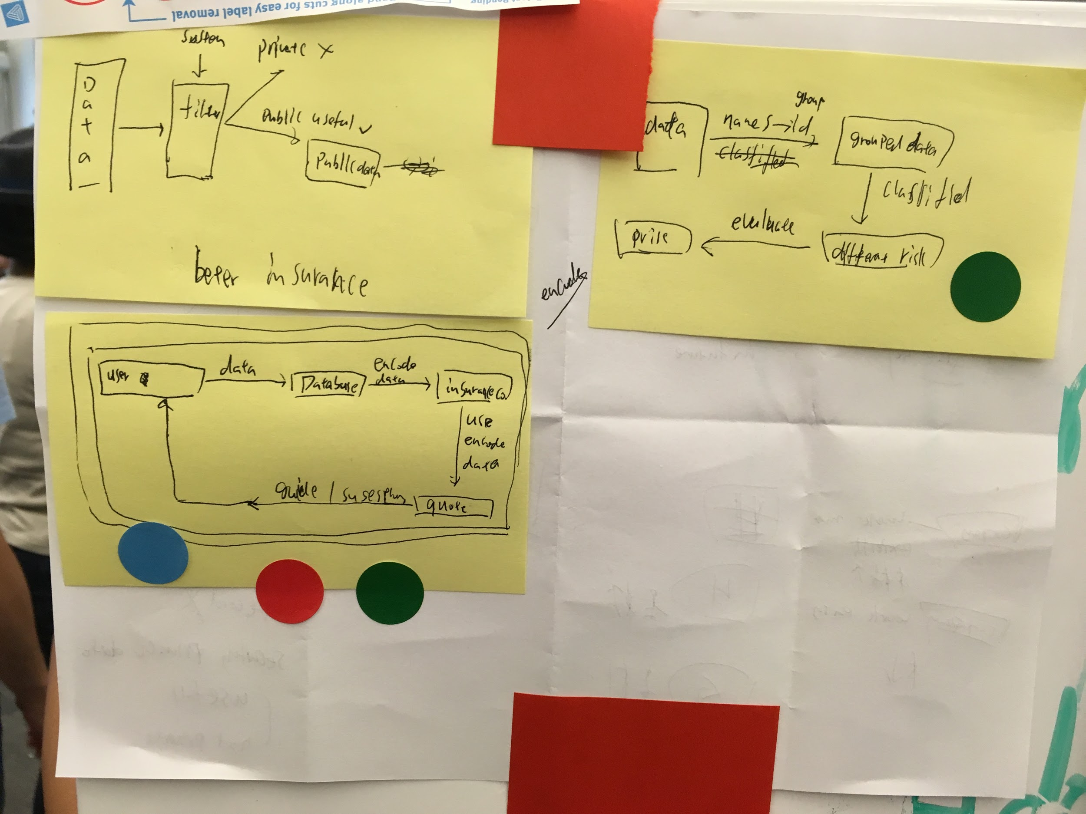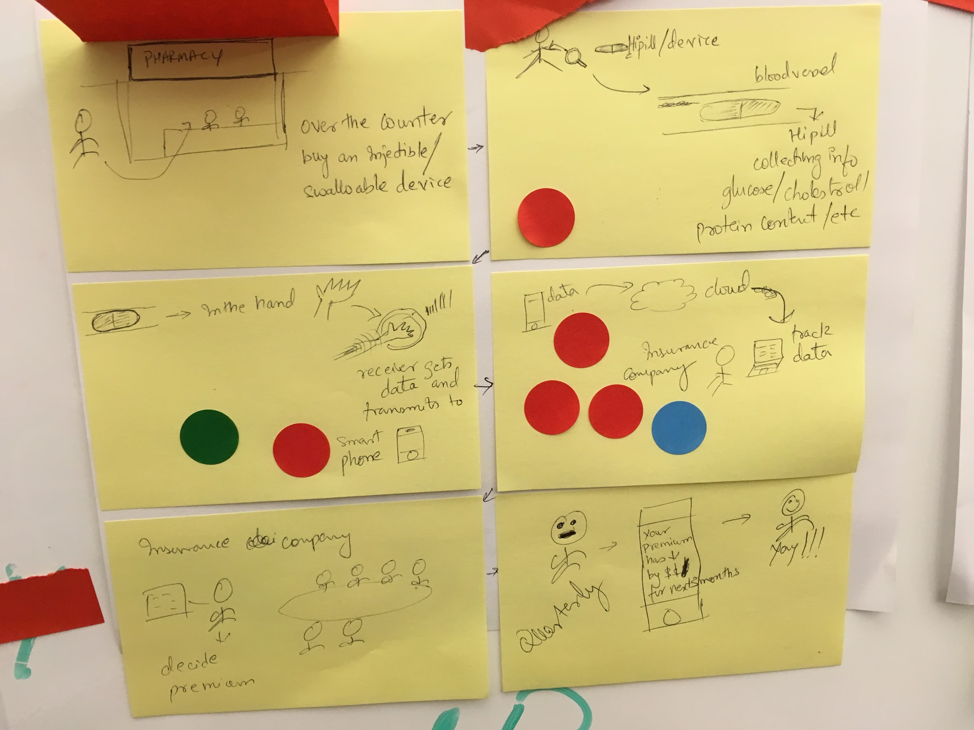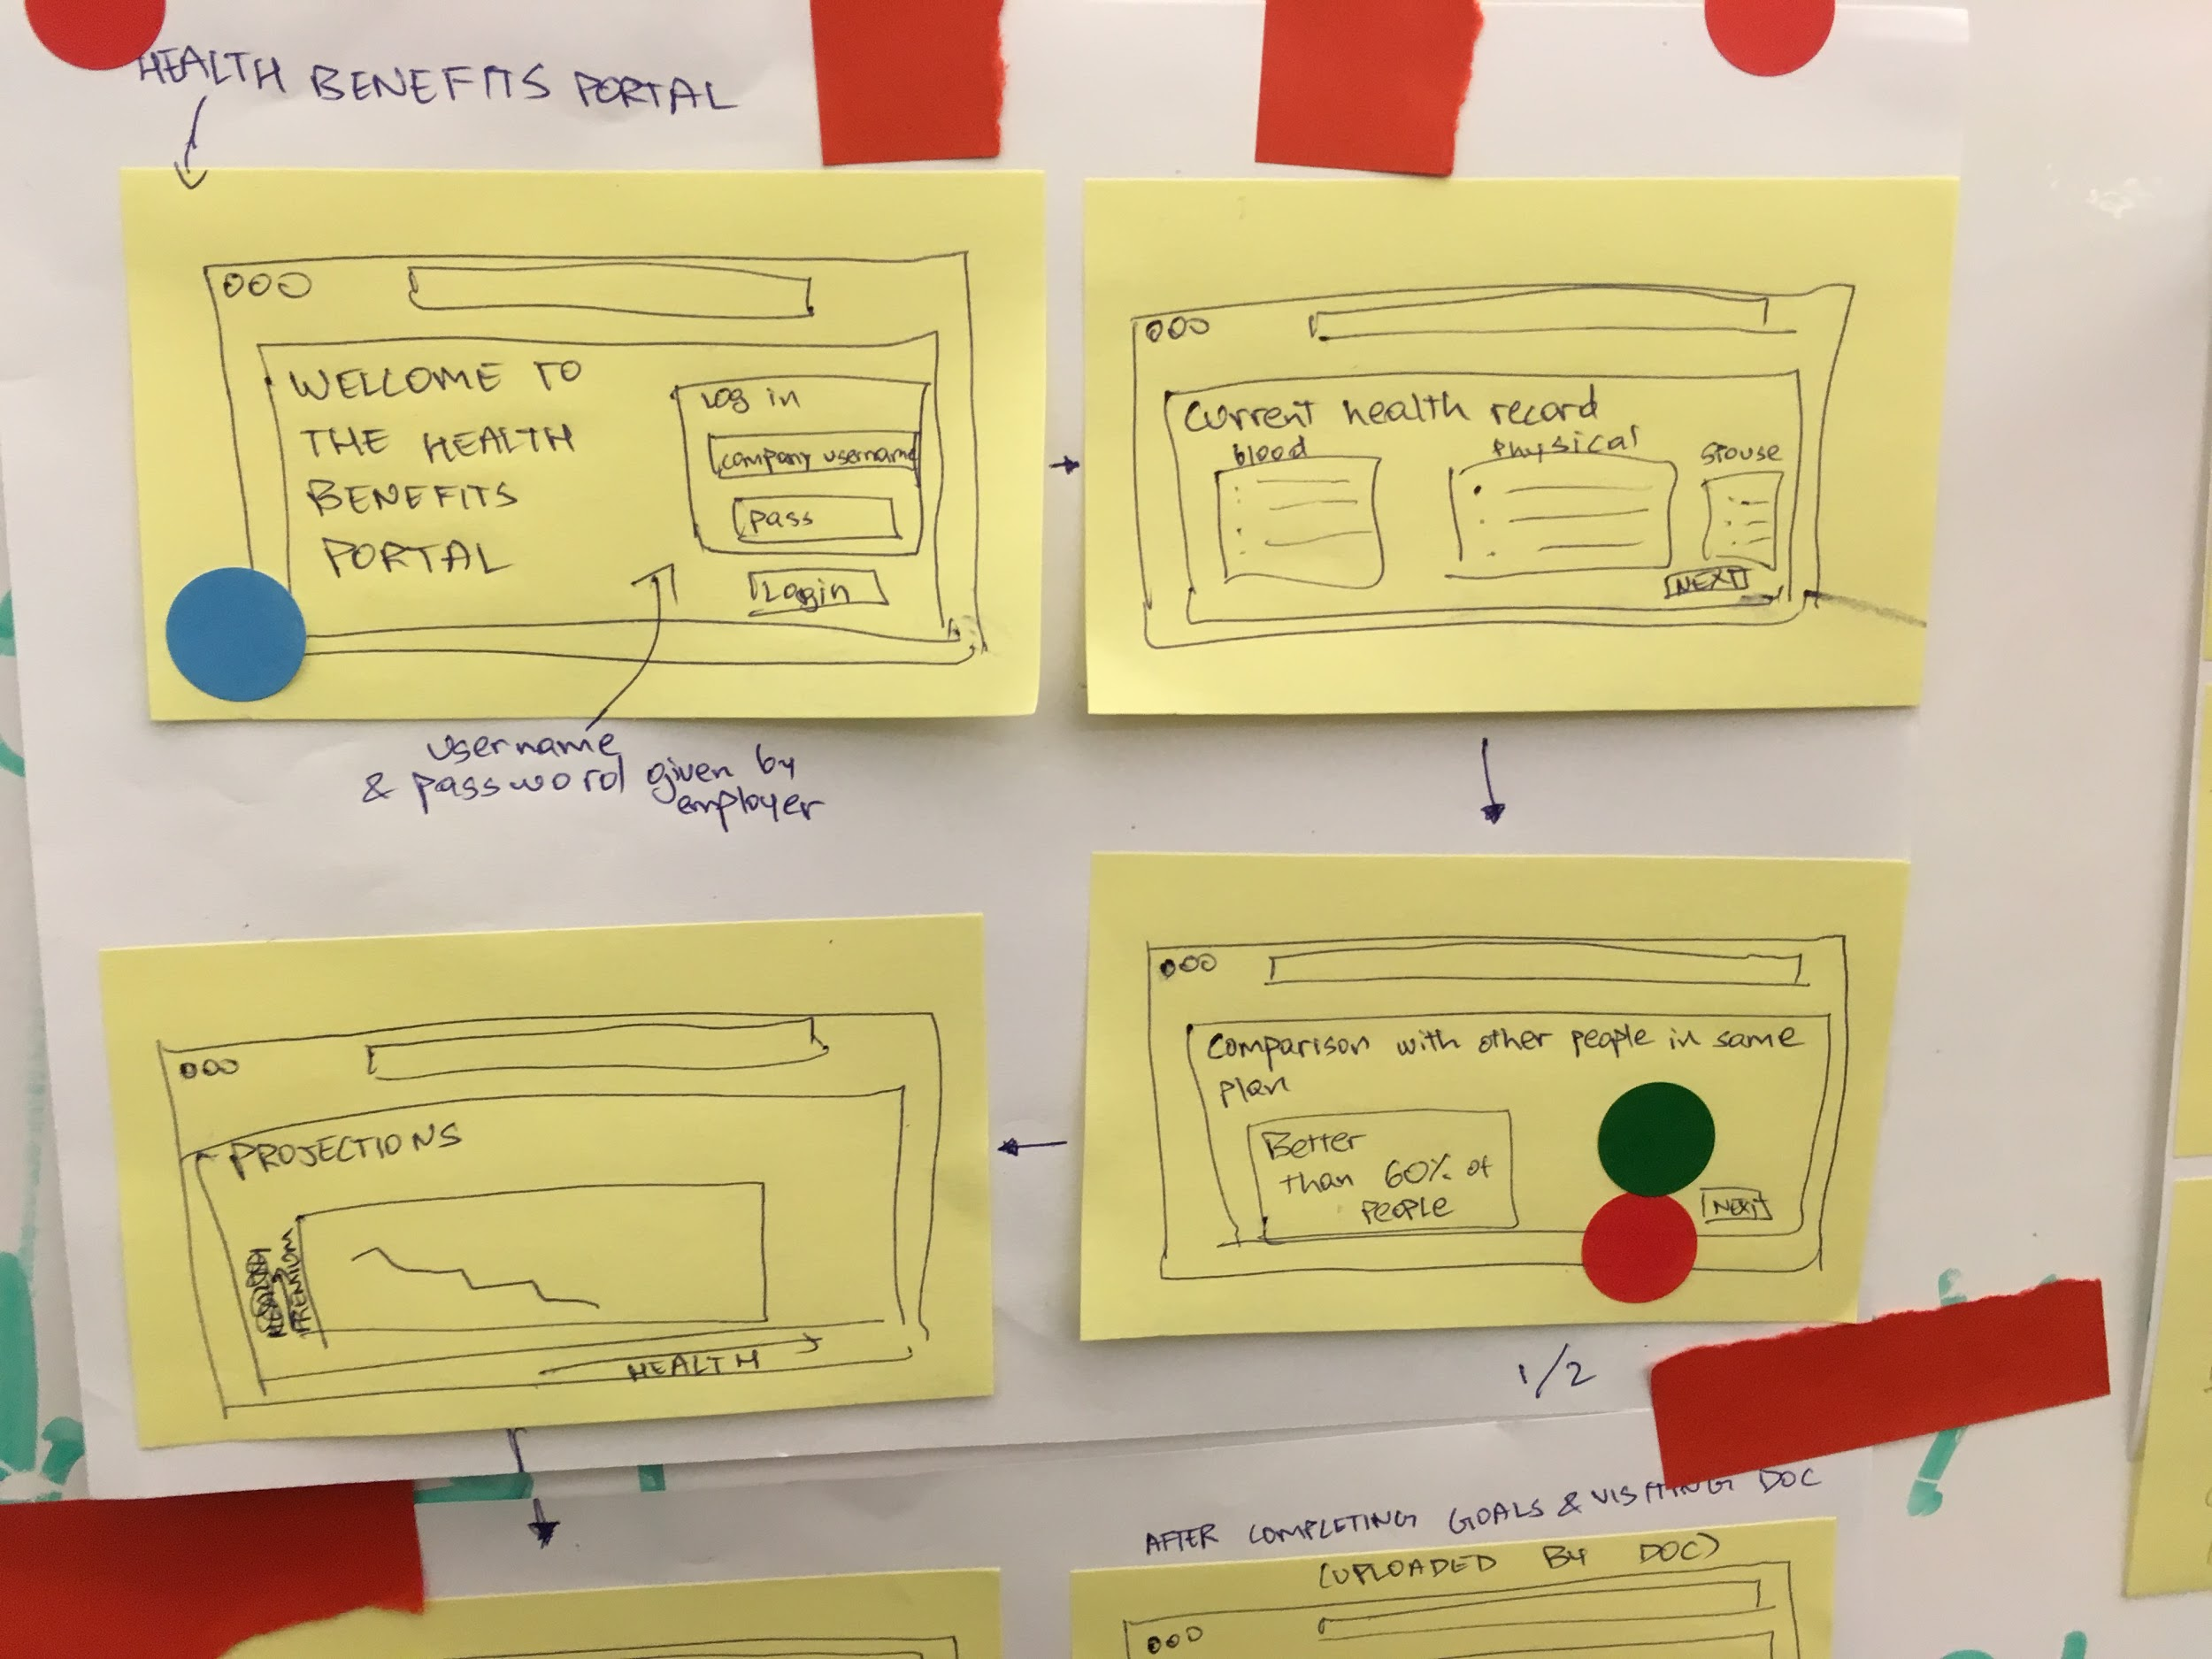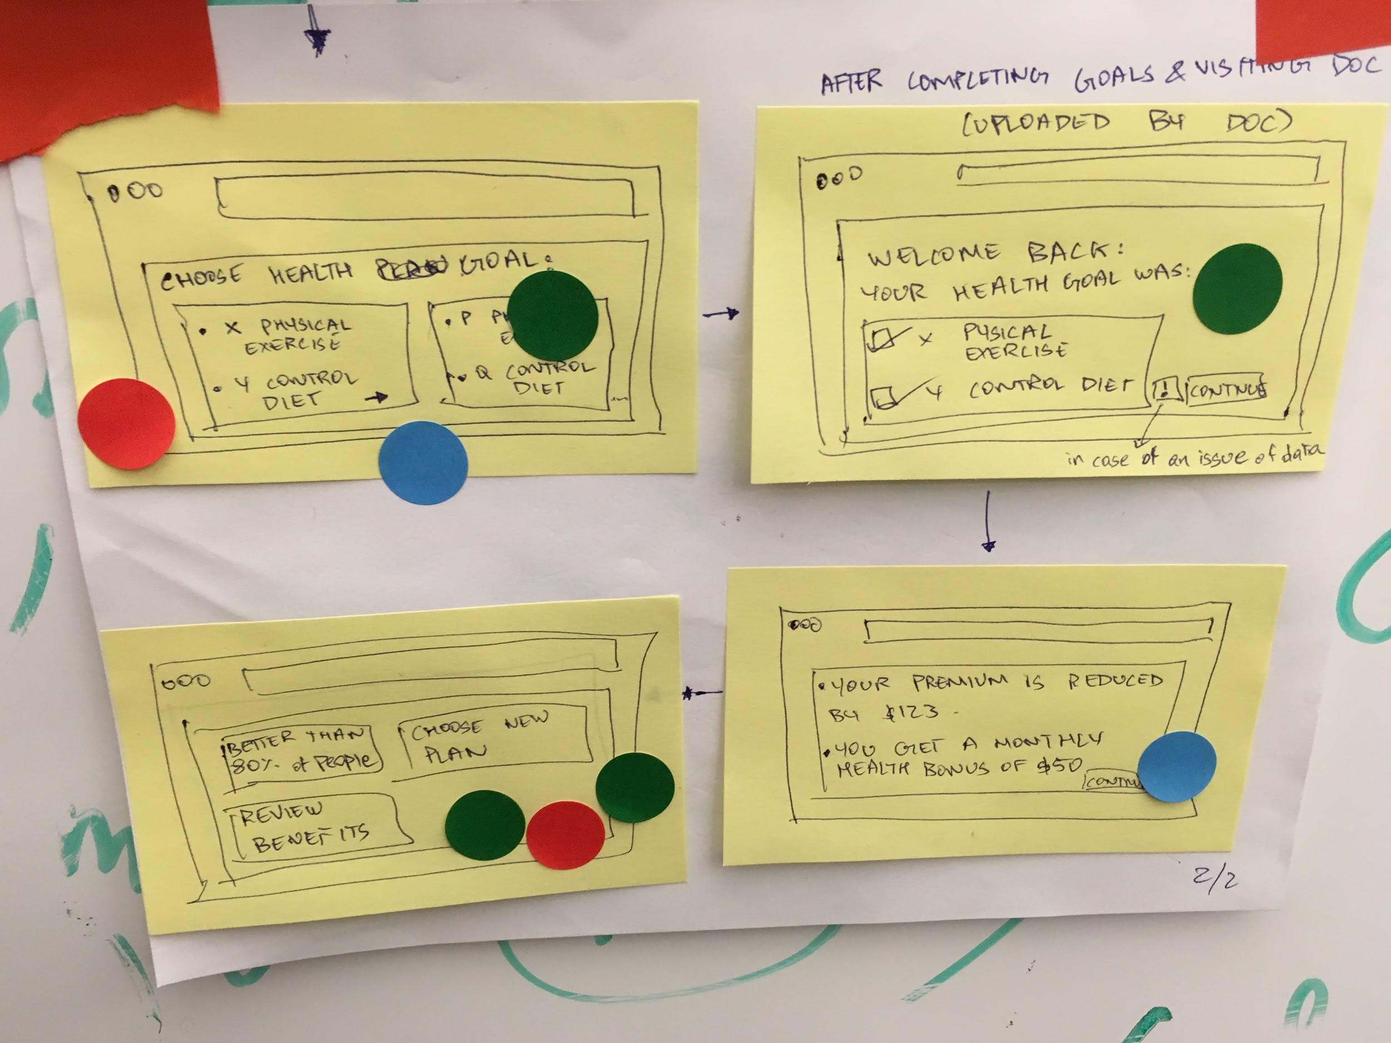

Critiques for the sketches:

**Jimmy:** Suggested we need to add element of privacy on the platform by encrypting our data, so that security of customer is maintained at all times, making the customer satisfied.

**Andrew:** Agreed that we need to have a health portal, where the user can see the health rate, or the number of people he/she is healthier than in the organization and an option to set healthgoals.

**Abhiram:** Agreed for the need for the use of a portal, and also suggested there be a mechanism to track the user’s health in real-time, with a device like a pill which can be ingested, and which then transmits the data to the insurance company to better profile the customer and accordingly adjust the premium rates.

**Utsav:** Suggested the need of a health portal within an organization, where the user can view the his/her health records and see them in comparison to the rest of the organization, look at ways to improve health and accordingly manage the insurance premium rates.

User Story 1: Instant appraisals for Car Accidents for faster claims management.

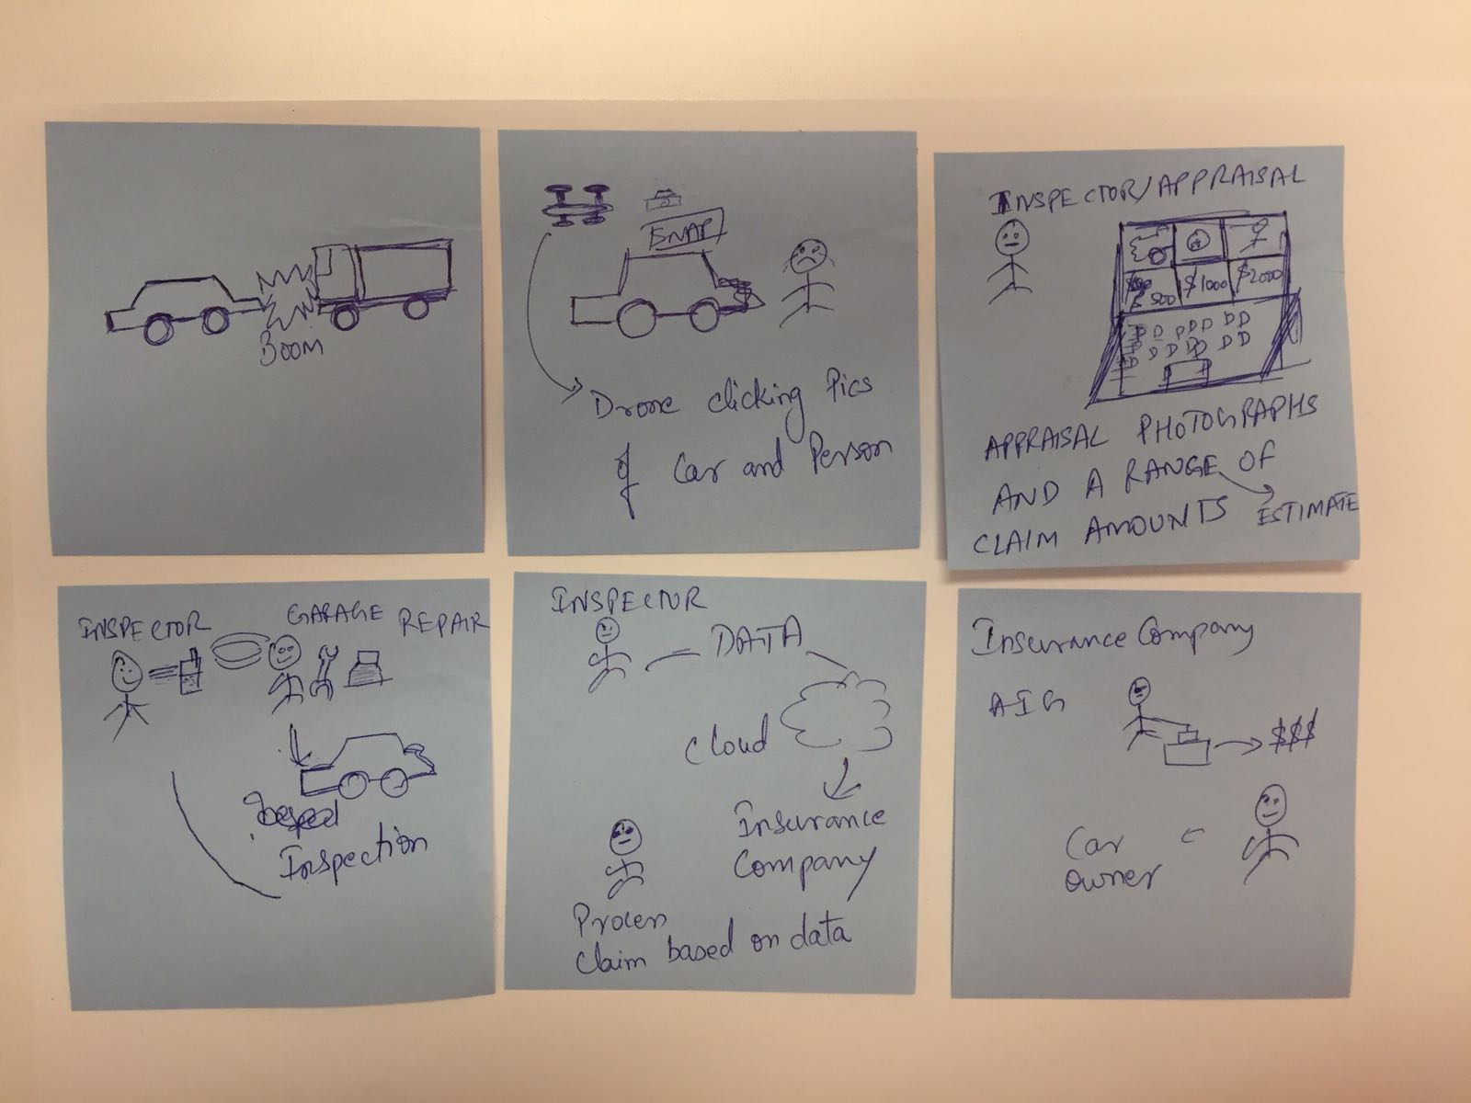

User Story 2: Third Party inspector in Car insurance market

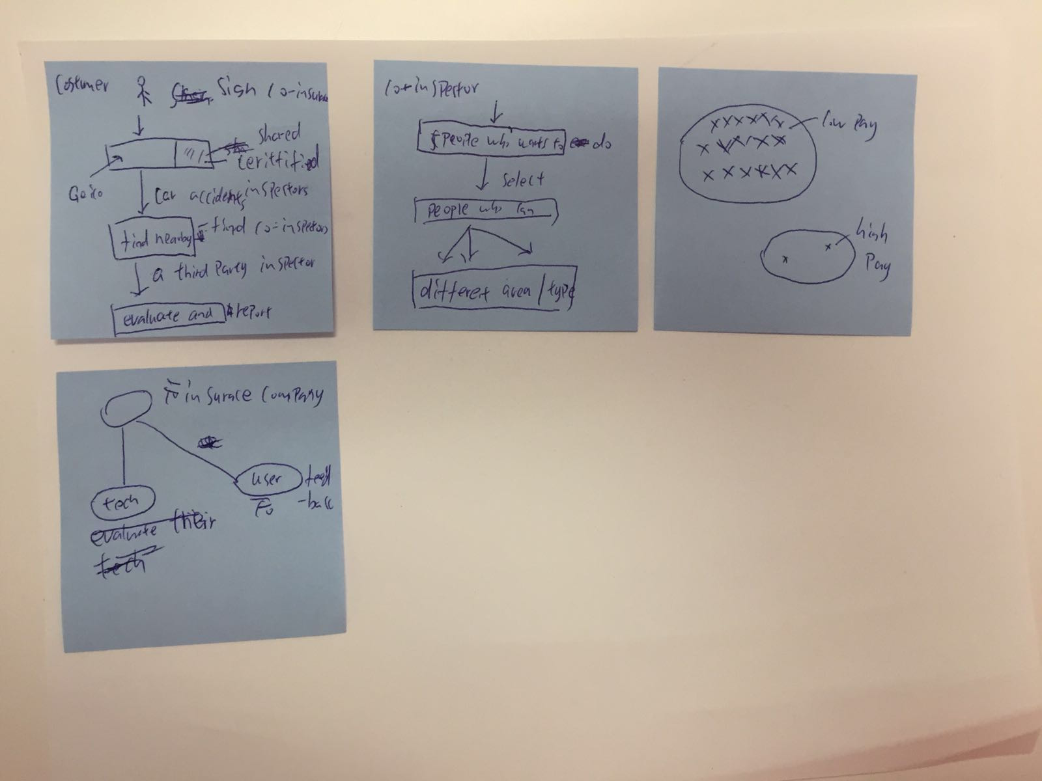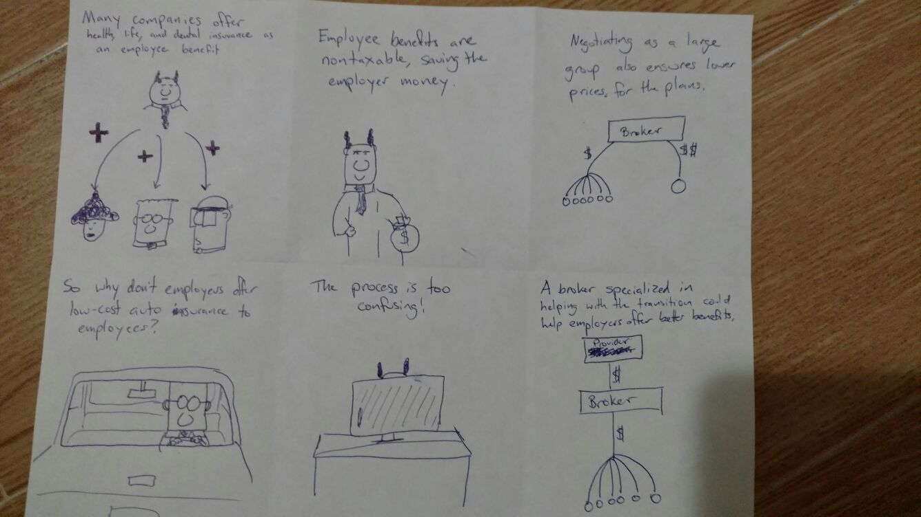

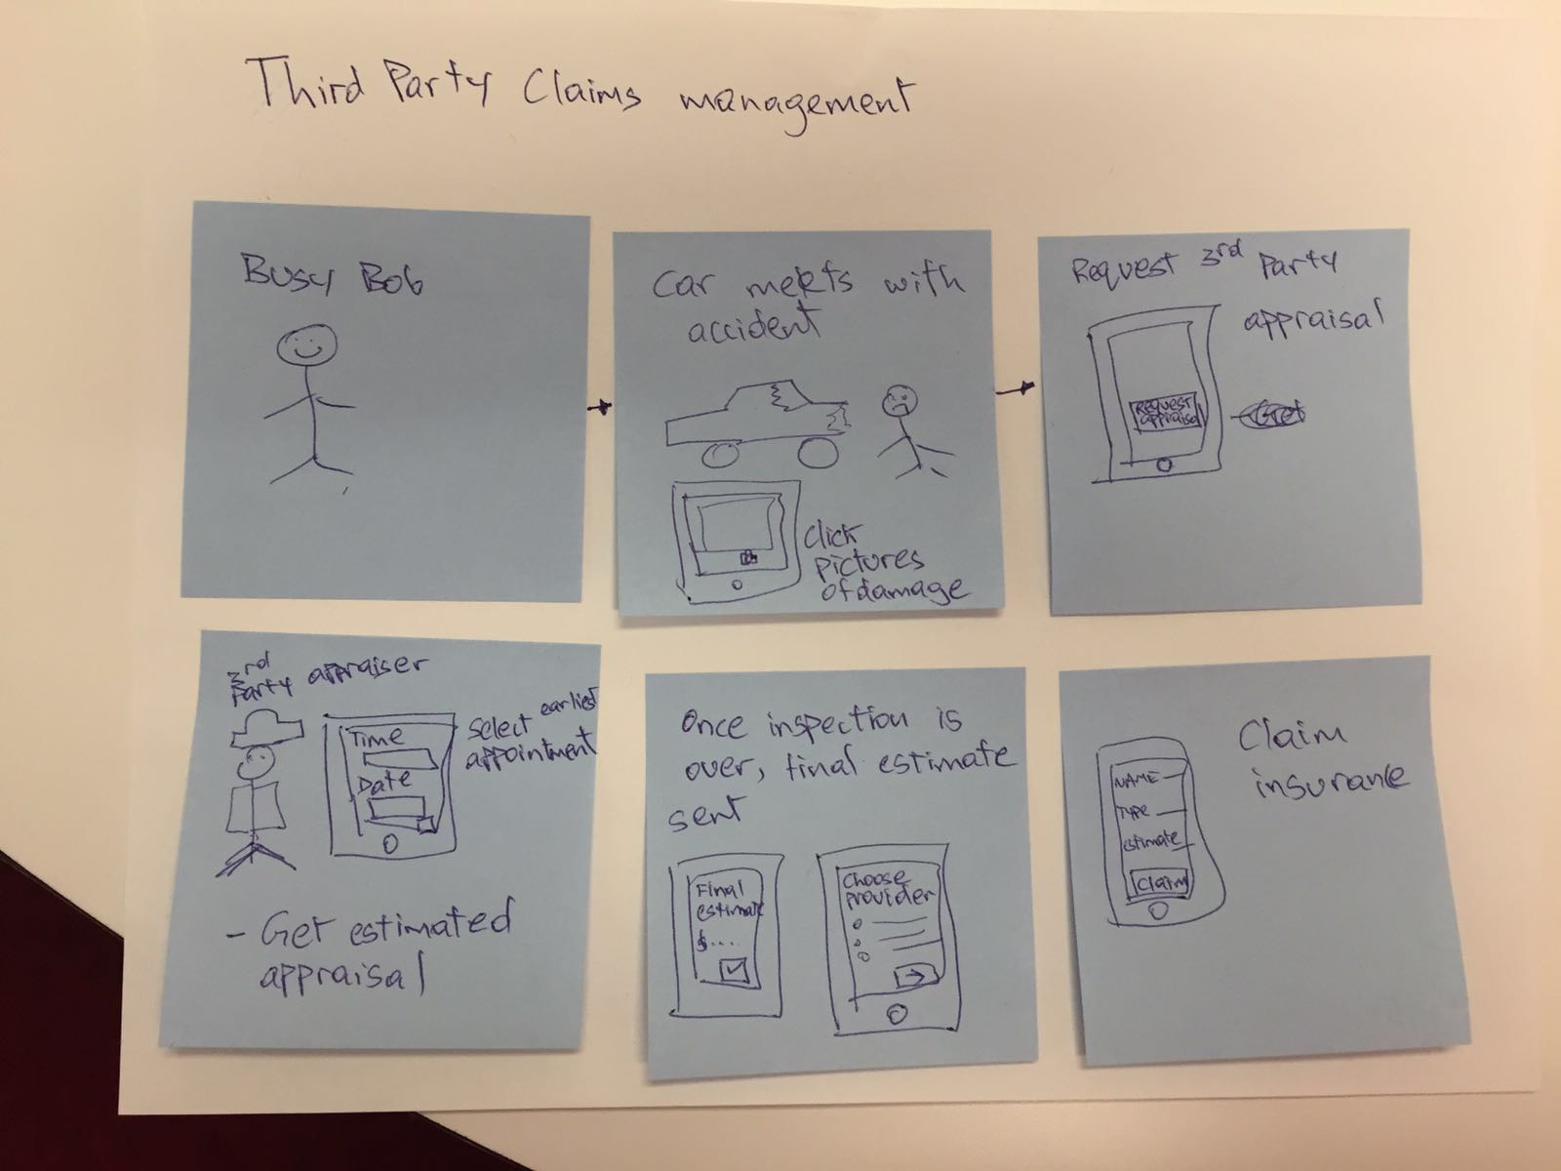

The cumulative user story that was generated is:

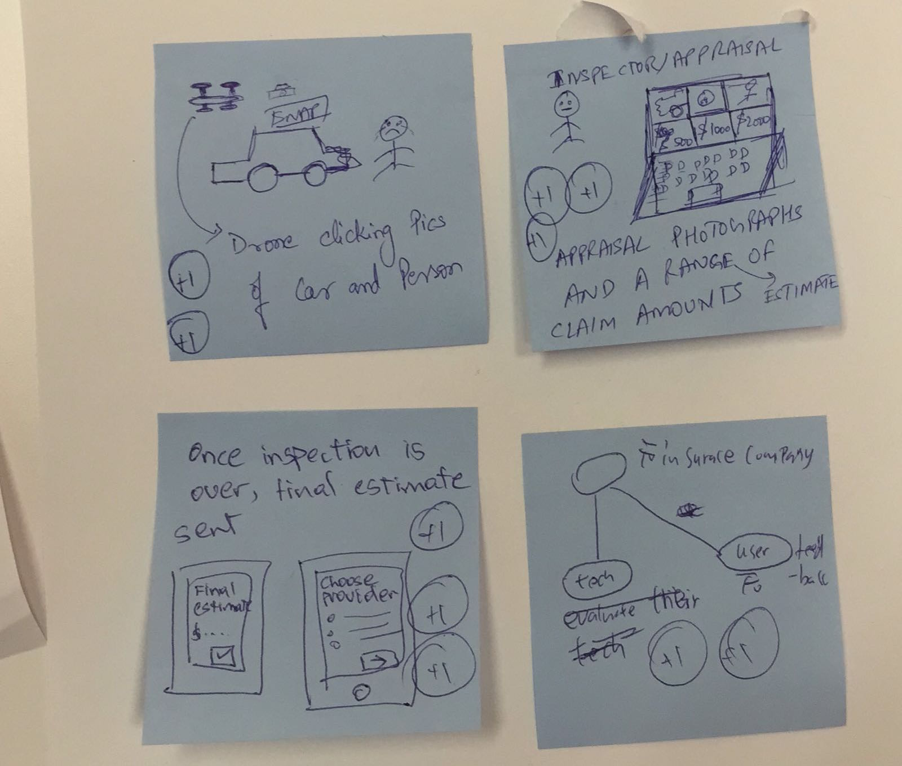

Narrative 1:

A car is hit by a truck in the middle of the road and suffers heavy external damage. Even before the car is towed to an auto shop for repair, the driver calls his insurance company and a Relationship Manager sends out a drone from the nearest location. The drone which is partly controlled by a human clicks pictures of the damaged car and sends them out to the cloud where it can be accessed by the RM.

The RM gives an estimate to the driver after which it is confirmed by the autoshop and the repair begins. Once the repair is completed, an invoice is generated which is later tallied by the RM’s team and the claim is settled by the Insurance Company.

Narrative 2:

People usually sign an agreement to one insurance company and only that company take care of their customers. However, if one client catches a car accident and it is hard for the insurance company come, is there other ways to deal it? Yes, we can. We can provide customers third party inspectors which are selected people who like to earn extra money also know cars well. These people are shared by many insurance companies and each time they find the nearby inspectors. Also, if one car is too far from everyone, the one who does it will get more paid.

Another thing is that we need to do two side evaluation, one is users’ feedback, which let insurance companies know the attitude of the inspectors. Also we need to do like bite-accident, we randomly choose some of the accident and let insurance companies inspectors pretend to be the driver and evaluate the third party inspectors.